Adrienne De Luna
Final Project - Grant
S604 FEIL
Professor Kym Kramer
April 27, 2025

Grant Overview:
ALDI Community Gift Card Program
The ALDI Community Gift Card (ACGC) program offers gifts valued between $100 and $1,000 to qualified nonprofits and schools committed to supporting after-school and out-of-school youth programs. This initiative also extends to food banks and pantries seeking to purchase essential products. Whether your mission focuses on youth development or addressing food insecurity in your community, we invite you to apply for support.
Application Details:
- Application Period: Opens March 3, 2025, and closes November 30, 2025.
- Eligibility: Through this program, we collaborate with local 501(c)(3) nonprofit organizations, including schools, to benefit all children in the community. Whether your mission focuses on supporting children through education, arts, athletics, or addressing food insecurity, we encourage you to apply for support from the ALDI Community Gift Card Program.
- Applicants must be involved in an after-school or out-of-school program, or a food bank/pantry seeking to purchase products.
- The eligibility quiz and application must be submitted by an official representative or employee of the organization applying for support.
- A copy of tax documents or registration must be attached with your application.
- Please note that gift cards cannot be mailed to P.O. Box addresses.
- For technical assistance, please contact Grants Connect Support.
Why I chose this grant:
I started an after-school snack initiative my first year as a Youth Services Librarian (https://blogs.iu.edu/dlis/2024/01/31/mlis-student-spotlight-adrienne-de-luna-luddy-indianapolis-library-student-serving-her-community-one-snack-at-a-time/). The program is 100% donation-based, but it is getting difficult to rely on the community to continually donate pre-packaged snacks, so I applied for this grant to help supplement those donations and keep the program running.
I actually just submitted the application, and the completed form is as follows:

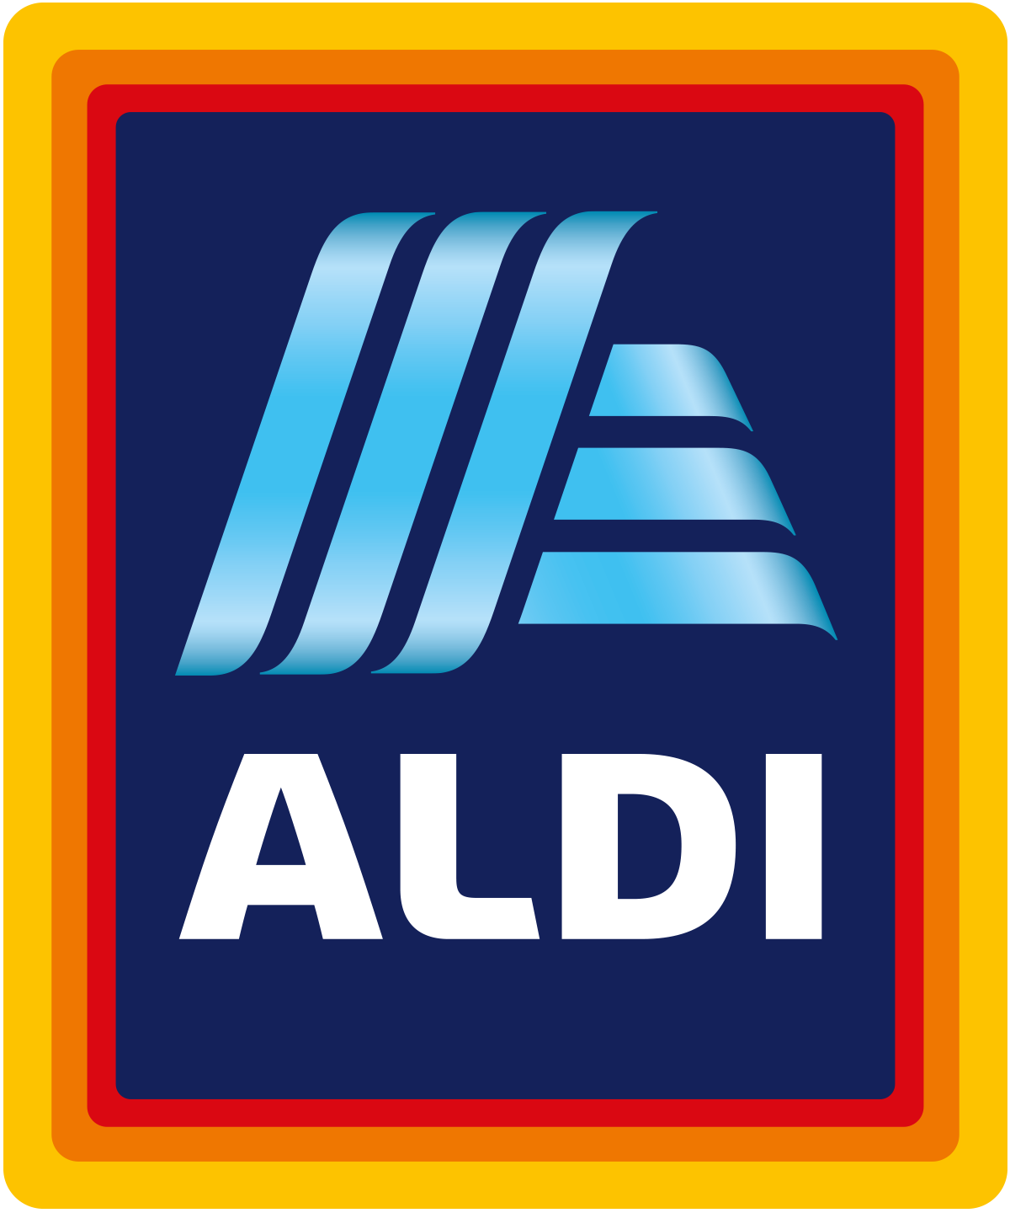

Application ID 1714071

Submitted Apr 24, 2025

Status Awaiting review

Applicant(s) Adrienne DeLuna (adeluna@whiting.lib.in.us)

Organization FRIENDS OF THE WHITING PUBLIC LIBRARY INC
35-1897562
1735 OLIVER ST, WHITING, IN, 46394-1722, US

Program and cycle ALDI Community Gift Card Program
ALDI Community Gift Card Program 2025

Tags No tags

Forms ALDI Community Gift Card Program Application

ALDI Community Gift Card Program Application
Submitted on Apr 24, 2025
FRIENDS OF THE WHITING PUBLIC LIBRARY INC
35-1897562

Name

Adrienne De Luna

Title

Youth Services Librarian

Has your organization received grant funding from ALDI in 2025?

No, I am a new applicant

Applications are reviewed at a regional level, based on ALDI store location. To find your divisional location, please use this link and search for the store closest to your organization/chapter. Once located, please select the division from the dropdown below.

What is your division?

Valparaiso, Indiana
Please provide the address to which gift cards should be mailed if awarded. Gift cards are not able to ship to a P.O. Box address.

Street address 1

1735 Oliver St

Street address 2

No answer City Whiting State Indiana Zip code 46394

Contact name (c/o) for grant

Adrienne De Luna

Total Donation Request

$1,000.00 USD

Number of gift cards

1

Value of each gift card

$1,000.00 USD

What is the primary focus of your organization or initiative?

Food Insecurity

What is the mission of your organization?

The mission of Whiting Public Library is to enrich lives, build community, and inspire lifelong learning by providing equitable access to information, resources, and programs for all. We are especially committed to supporting local youth through educational and enrichment opportunities that foster curiosity, creativity, and well- being—both during the school year and throughout the summer.

Provide a brief description of your organization and programs

Whiting Public Library serves the diverse community of Whiting, Indiana, offering free access to books, digital resources, and educational programs for all ages. Our Youth Services Department provides a wide range of engaging programs for children and teens, including story times, STEM activities, literacy initiatives, and seasonal events. We are especially focused on supporting local families by offering safe, welcoming spaces and essential services—such as after-school programs and summer reading clubs—that promote learning, creativity, and community connection.

Is this a program or an event?

Existing Program

Title of Programt or Event

After School Snack Initiative

What day is the event or what day does the program or event begin?

05/01/25

Give a brief description of the program or event and how the funds will be used:

Whiting Public Library’s existing 100% donation-based After School Snack Initiative provides free snacks and food to children after school and during summer. With nearly 70% of local students qualifying for free/reduced lunch and over 15% living in poverty, the program helps combat food insecurity and supports youth in a safe, welcoming environment that encourages learning and community connection.

Select the primary age range of population impacted by this program or event

0-18 (Children)

How many participants do you expect or will be impacted by the program or event?

200

Please select the geographical reach of the program or event

Neighborhood

Please provide any metrics, key performance indicators (KPIs) you plan to measure and describe the results you expect to achieve. Ex. Number of individuals served, the measurement of impact made, etc.

We aim to serve 25–45 children each weekday through the After School Snack Initiative, totaling over 5,000 individual snack distributions annually. Key performance indicators include the number of snacks distributed, participant engagement in library programs, and informal feedback from families. We expect increased library usage, improved program attendance, and reduced food insecurity among participating youth.

What demographics will benefit from the program or event?

Records: 9
Demographic | Percentage
African American/Black | 4.7%
Asian | 0.6%
Hispanic or Latino | 50.5%
Native American or Alaskan Native | 0.5%
Native Hawaiian or Other Pacific Islander | 0%
White | 43.2%
Two or More Races | 0.5%
Not Specified | 0%
Other | 0%

Please select the primary populations impacted by this program or event

Low Income

Please share the link to your organization's website

whiting.lib.in.us
Please list any social media handles below
Please list any social media handles below
https://www.facebook.com/WhitingPublicLibrary
https://www.instagram.com/whiting_public_library/
Please list any social media handles below
Please list any social media handles below
No answer
No answer

Upload your W-9
Upload your IRS determination letter (optional)
See tax exempt.pdf
No file uploaded
Upload your Project/Program/Event Budget (optional)
Other Attachment (optional)

No file uploaded
No file uploaded

